

**KABARAK UNIVERSITY**

**SCHOOL OF SCIENCE ENGINEERING AND TECHNOLOGY**

**DEPARTMENT OF COMPUTER SCIENCE AND IT**

**TEAM PROJECT BBIT 324**

**PROJECT TITLE: WEB BASED POLICE BOOKING SYSTEM**

Submitted on:

**JUNE,2021**

By:

**OCHIENG V. EDWIN BBIT/MG/0798/05/17**

**LABAN TONUI BBIT/M/0052/01/19**

**LAURYN KIMELI BBIT/MG/2856/09/18**

Supervised by:

**Lecturer Martin Kimutai**

**Project Submitted Towards the Partial fulfilment For the Award in Bachelor of Science in Business Information Technology.**

# DECLARATION

This report is our inventive work and any unsanctioned imitation or alteration of this documentation or parts of its contents is an abuse of legal rights under the copyright Act unless sanctioned by the creators of this project.

Name: Ochieng V. Edwin

Reg. No. Bbit/Mg/0798/05/17

Sign.: ..............................

Name: Laban Tonui

Reg. No. Bbit/M/0052/01/19

Sign.: ..............................

Name: Lauryn Kimeli

Reg. No. Bbit/Mg/2856/09/18

Sign.: ..............................

Date: 7th June 2021

**Supervised By:**

Name: Lecturer Kimutai Martin

Sign: ..............................

Date: 7th June 2021

# AKNOWLEDGEMENT

We would like to acknowledge our parents for supporting and permitting us to pursue this course. Kabarak University for giving us the environment and opportunity to carry out this project and the support from our lecturers who have given us the knowledge and supervision while undertaking this project. Special gratitude to our course colleagues for their support and academic guidance throughout the study.

# ABSTRACT

This project paper recognizes the challenges of records management facing police departments in Kenya and the inevitability of the status of application of computerized booking systems. Used to advance record management while using information systems that aid in efficient storage, processing, retrieval, and manipulation of information by the police administration. Limitations towards application of computerized records systems are also described. Security problems have become a major concern in most urban settlements across the globe. The use of technology can be incorporated into the security systems to enhance operational measures that have been deployed. The study employed design science to develop the proposed system. Primary data was collected from one hundred members of the public and twenty-eight police officers serving within Central police division, Nakuru County. Chapter two looks at the literature review on computerized records management systems that have already been executed in developed countries. Chapter three expresses the agile system development methodology where several iteration descriptions has been viewed. The survey design used structured questionnaires which were administered to respondents independently, followed by developing a mobile-based application aimed at sealing the loopholes identified from the survey. A test was successful and all key operation tests had positive and acceptable outcomes. The survey indicated that, the current crime reporting method has numerous failures, which include late response to criminal cases, inaccuracy in documentation of acts, non-coordinate specific response by the police, longer duration for response, hence non resolving of issues raised by the public and human resource related issues such as bribes before the police can act on reported cases. Chapter four plots out the user and system requirements needed to meet the design and development of the system in alignment to the budget and project schedule. The findings of the study concluded that the current crime reporting and information collection system are part of the problem that negates the policing sector hence encouraging criminal acts. The study recommends that if the application will be used by the sector, then there is a need for training police officers on usage and massive education and awareness to the public as it presents a viable tool for solving crime, improving intelligence collection and reducing resource waste in the entire policing value chain. The publication then finishes with a depiction of the conclusions obtained after the examination of the problem. Further, provided are some recommendations basing on the information investigated for the project to come out as a reasonable reality.

# TABLE OF CONTENTS

DECLARATION i

AKNOWLEDGEMENT ii

ABSTRACT iii

TABLE OF CONTENTS iv

LIST OF TABLES vii

LIST OF FIGURES viii

CHAPTER ONE 1

INTRODUCTION 1

1.1 Background of Study 1

1.2 Problem Statement 2

1.3 Drawbacks of Existing System 3

1.4 Proposed Solution 3

1.5 Justification 3

1.6 Limitations 3

1.7 Objectives of the Project 3

1.7.1 Main objective 3

1.7.2 Specific objectives 4

1.8 Research Questions 4

CHAPTER TWO 5

LITERATURE REVIEW 5

2.1 Introduction 5

2.2 Global Security Status 5

2.3. State of Security in Kenya 5

2.4. Analysis of the Security Forces in Response to Crime Reports 5

2.5. Challenges Associated with Crime Reporting in Kenya 9

CHAPTER THREE 10

SYSTEM DEVELOPMENT METHODOLOGY 10

3.1 Introduction 10

3.2 Agile Software Development 10

3.2.1 Iteration 1 11

3.2.1 Iteration 2 11

3.3 Requirement Analysis, Specification and Feasibility Report 11

3.3.1 Introduction 11

3.3.2 Data Collection 11

3.3.3 Primary tools used: 12

3.4 Analysis of Research Findings 12

3.4.1 Feasibility report relating to the study of efficiency of old system and new system. 12

3.5 Feasibility Study 13

3.5.1 Technical Feasibility: 13

3.5.2 Economic Feasibility: 14

3.5.3 Operation Feasibility: 14

3.5.4 Schedule Feasibility: 14

3.5.5 Behavioral Feasibility 14

CHAPTER FOUR 15

SYSTEM DESIGN 15

4.1 Introduction 15

4.2 Logical Design: 15

4.3 Resources Required 18

4.4 Input Design 21

4.5 Output Design 23

4.6 Use case diagrams 24

4.7 Data Flow Diagram 27

4.7.1 Context flow diagram 27

4.7.2 Sequence diagram 30

4.7.3 Class Diagrams 31

4.8 Relational Database Management System (Rdbms): 31

4.8.1 Relationships: 31

4.8.2 Normalization: 32

4.9 Tables Structure 33

4.10 Budget Design 34

4.11 Project Schedule (Gantt Chart) 34

CHAPTER FIVE 35

5.0 SYSTEM IMPLEMENTATION AND TESTING 35

5.1 Introduction 35

5.2 Implementation Procedures 36

5.4 Training on the Application Software 37

5.5 Operational Document 37

5.6 System Maintenance 38

5.7 Screenshots 38

CONCLUSION 42

RECOMMENDATIONS 43

REFERENCES 44

APPENDICES 45

Appendix I: Research Questionnaire for Police Officers 45

Appendix IV: Sample Codes 47

# LIST OF TABLES

Table 1: Number of respondents involved in the knowledge acquisition process 12

Table 2: Ratings for advantages for implementing a new system over the old system 13

Table 3:Functional Requirements as per Reporter 19

Table 4:Functional Requirements as per the Head of Departments 20

Table 5:responders’ team 33

Table 6:staff 33

Table 7:system settings 33

Table 8:stations 33

Table 9:desk officer 33

Table 10:booking action 33

Table 11:booking 33

Table 12: Budget 34

Table 13: Gantt chart 34

# LIST OF FIGURES

Figure 1: Showing Agile system development methodology 11

Figure 2: Graphical representation of the comparison between new and old system advantages 13

Figure 3:PHP server communication 21

Figure 4: Use case diagram showing how the actor will interact with the system. 24

Figure 5:data flow diagram 27

Figure 6:context flow diagram 27

Figure 7:level 1 admin DFD 28

Figure 8:Level 2 DFD- Administrator 29

Figure 9:Level 1 DFD- User 29

Figure 10:Level 2 DFD- User 30

Figure 11: Sequence Diagram 30

Figure 12:Class Diagram 31

Figure 13:account creation 38

Figure 14:officer login 38

Figure 15:admin login 38

Figure 16:officer dashboard 38

Figure 17:bookings log 39

Figure 18:officer account management 39

Figure 19:booking entry 39

Figure 20:admin dashboard 40

Figure 21:bookings pending verification 40

Figure 22:stations management 40

Figure 23:staff management 41

Figure 24:dashboard management 41

# CHAPTER ONE

INTRODUCTION

The Kenya Police is a law enforcement institution set up by the Kenyan government tasked with the responsibility of sustaining law and order in the society. They are also accountable for averting and resolving crimes in a judicious and efficient means. For this to ensue, there is an understandable need for an efficient administrative regulator over procedures that involve the systematic process that leads to the management and control of crimes in the country. Thus, a system of providing the Kenyan Police with information regarding criminal records and the various descriptions of their crimes in the past, will help in a complete criminal profiling stored in a records management information system that can be easily retrieved, updated, and processed any time with ease.

Presently with the growing crime rates, criminal history files have been dispersed all over with courts and administration police running out of storage space for criminal file documents. This makes retrieving, updating, and processing these records hard and cumbersome consequential in improper judgments or merely corrupting the process.

The project titled as “Police Crime Portal” is a web-based application. This software provides facility for reporting online crimes, complaints, missing persons, show most wanted person details mailing. The proposed system looks at eradicating the old filing methods with computerized police booking system that is going to help in records management using an information system that will advance how criminal records are stored, processed, updated, retrieved, and processed efficiently. Any Number of clients can connect to the server. Each user first makes their login to sever to show their availability. This will be probable because of a database management system that will manage these tasks and in addition generate reports of the queried records from the database. This will make records supervision easier at the police administrative level and at the judicial system.

## 1.1 Background of Study

Since the commencement of the 20th century there have been a lot of developments in the law enforcement system especially in the developed countries. From the use of information systems for computerized criminal history, criminal charting information systems and police records management information systems. In the United States of America, these systems allow for every citizen to be predictable by the state not only by virtue of birth registration but also by an information system where profile databases are created all over the state such that if you commit a crime your finger prints or DNA would be run through their systems and you would be identified by the system through forensic algorithms that match to your stored biometrics in the database. In addition, citizen records in the database are updated such that if you were to relocate to a new address, your records in the information systems would reflect your current information.

Looking at developing countries, specifically Kenya, since the commencement of the 20th century and after independence to date, our judicial system has shown deprivation at a very fast pace. Since it is blemished with corruption, inefficient criminal records management, and administrative disorganization. The current system in operation in Kenya uses the traditional filing system whereby when a person has broken the law or commits a crime, he or she is manually entered in a book through hand written descriptions of the nature of crime. A file document is later created and stored as a future reference in a court hearing.

These files are in most cases momentary and may disappear and never referred to again. The judiciary refers to these filed documents for court proceedings. If a case was to be referred to another month or year, the file may be displaced resulting into a slow jumbled judicial system.

Currently with the increasing crime rates, criminal history files have been scattered all over with courts and administration police running out of storage space for criminal file documents. This makes retrieving, updating, and processing these records hard and cumbersome resulting in improper judgments or merely bribing the process.

The proposed system looks at eliminating the old filing methods with computerized police booking system that is going to help in records management using an information system that will improve how criminal records are stored, processed, updated, retrieved, and processed efficiently. This will be conceivable because of a database management system that will manage these tasks and in addition generate reports of the queried records from the database. This will make records handling easier at the police administrative level and at the judicial system.

## 1.2 Problem Statement

The current system consents to manual entry of names of offenders in a book in a police station. New cases in the police station are booked manually (hand written). With their particulars description being entered into a book stored in the police station where no proper filing system exist so that if the suspect was to be taken to court his details would be well presented.

1.3 Drawbacks of Existing System

* More man power.
* Time consuming.
* Consumes large volume of pare work.
* Needs manual calculations.
* No direct role for the higher officials.
* Damage of machines due to lack of attention.

1.4 Proposed Solution

The proposed system is meant to create an efficient booking system whereby information and records are managed aptly to meet standards necessary for rationalization management of the Kenya police records system. The proposed system aims at making the registration process of offenders to be well streamlined for future reference. The proposed system will help the user to reduce the workload and mental conflict. The proposed system helps the user to work user friendly and he can easily do his jobs without time lagging.

## 1.5 Justification

Web-based police booking system will largely help hurry up the exchange of criminal history records among regional police departments for a more comprehensive crime mapping process in the administration police.

Computerized booking system is going to lower the cost of storage space requirements since all the information will be stored in a server that occupies less space than filing cabinets.

Most importantly Information availability will be ensured overtime since the information stored in a distributed database compared to manual filing systems whereby files get lost or misplaced.

## 1.6 Limitations

The major limitation of the computerized booking system is the cost implementation of distributed computing whereby a central database will be provided where processing, storage, retrieval, updating of records will take place.

## 1.7 Objectives of the Project

1.7.1 Main objective

To modernize the police booking system by computerizing and enabling a data base management system for the electronic storage of the records then networking the entire system so that records in the system can always be cross checked by any police department database nationwide.

1.7.2 Specific objectives

To reducing specific record searching intensity and retrieval of personnel records from a central and shared database.

To make records processing much efficient due to presence of a database management system that allows for distributed computing and resource sharing.

To back up the database on different computers both remote and locally to ensure records can be retrieved even after a system failure.

To protect the records from accidental alteration, information corruption by viruses and unauthorized access and damage by providing authentication and authorization credentials of personnel that will be using the booking system and provision of secure physical locking cabinets.

## 1.8 Research Questions

1. How the proposed system can aid in reducing specific record searching intensity and retrieval of personnel records from a central and shared database?
2. How the proposed system can make records processing much efficient due to presence of a database management system that allows for distributed computing and resource sharing?
3. How the proposed system will back up the database on different computers both remote and locally to ensure records can be retrieved even after a system failure?

# CHAPTER TWO

LITERATURE REVIEW

1. Introduction

This section analyzed the current security situation within the city of Nakuru and the improvements that have been made to the situation. Security flaws that have been witnessed in the city have been analyzed and recommendations made on how they would have been avoided and how they can be managed in the future. Technology has been examined to determine how it would have been useful in these situations. There are some challenges that victims face when reporting crimes to the relevant authorities. These challenges have been examined to determine how they can be improved.

2.2 Global Security Status

The state of security has become a great issue globally. For example, terrorism and radicalization has become a great problem in almost all major economies. (Goodrich, 2012).

1. State of Security in Kenya

Currently, the main source of criminal information and reporting is the reports developed from the police investigations and occurrence books at the police stations across the country (Goodrich, 2012). The police often rely on the use of public information to piece together their investigation. The process of reporting crimes is generally slow in Kenya and ineffective. Getting through to the designated phone lines is often difficult and faces numerous technical barriers. Previous studies in the same region have revealed that corruption is one of the major challenges that have hindered crime-fighting within the country.

Currently, the main source of criminal information and reporting is the reports developed from the police investigations and occurrence books at the police stations across the country (Goodrich, 2012). The police often rely on the use of public information to piece together their investigation. The process of reporting crimes is generally slow in Kenya and ineffective. Getting through to the designated phone lines is often difficult and faces numerous technical barriers. Previous studies in the same region have revealed that corruption is one of the major challenges that have hindered crime-fighting within the country.

1. Analysis of the Security Forces in Response to Crime Reports

Security agencies are tasked with the responsibility of conducting the investigations on criminal activities that have taken place. Statistics indicate that the level of crime often reduces as the case are being solved. Reporting the criminal activities to the security agencies is highly dependent on the victims and the means of communication with the security agencies. The security agencies then initiate the relevant investigations to ensure that they are completed within the shortest time possible and the culprit is apprehended (Pokharel, Muturi & Muturi, 2003).

Security agencies are tasked with the responsibility of conducting the investigations on criminal activities that have taken place. Statistics indicate that the level of crime often reduces as the case are being solved. Reporting the criminal activities to the security agencies is highly dependent on the victims and the means of communication with the security agencies. The security agencies then initiate the relevant investigations to ensure that they are completed within the shortest time possible and the culprit is apprehended (Pokharel, Muturi & Muturi, 2003).

The state of security has become a great issue globally. For example, terrorism and radicalization has become a great problem in almost all major economies. The United States of America will forever remember the terrorism attack of September 11, 2011 (Goodrich, 2012).

The *Wanganui computer* was a mainframe computer built to hold records such as criminal convictions and car and gun licenses. At the time it was deemed ground-breaking, with Minister of Police Alan McCready describing it as "probably the most significant crime-fighting weapon ever brought to bear against lawlessness in this country" (Wellington, Randall Jackson, 2005).

The *Police National Computer* (PNC) is a [computer](https://en.wikipedia.org/wiki/Computer) system used extensively by [law enforcement organizations across the United Kingdom](https://en.wikipedia.org/wiki/Policing_in_the_United_Kingdom) It went live in 1974 and now consists of several databases available 24 hours a day, giving access to information of national and local significance. (Marlaine Hoffman, 1974).

The PNC is based on a Fujitsu BS2000/OSD S200 mainframe with recent PNC applications held on UNIX servers. There are around 26,000 directly connected terminals and 25,000 terminals which are connected via local police force computer systems. The mainframe is connected to the end user by a multitude of ways, for high volume users (i.e., other police forces) via secure IP network, for low volume users a secure dial-up link provided by Cable & Wireless (Marlaine Hoffman, 1974).

Until the 1960’s, the Federal Bureau of investigation (FBI) criminal history records were maintained on paper in manual files. Manual files have grown so large and cumbersome that response time has become a serious problem. The computer technology of the 1960’s provided the first practical opportunity. Thus, 1963 marked the initial FBI use of computer technology to process individual criminal records for Federal offenders, and led eventually to the establishment of NCIC. This center began operations on January 27, 1967, to create automated files of wanted persons and stolen vehicles. (*Assessment of the National Crime Information Center and Computerized Criminal History System,* Washington, D. C., December 1978,).

The Federal Bureau of Investigation’s criminal history records were maintained on paper, and were created and updated manually (typewriter or handwriting). While this approach appeared to be satisfactory for many years, the increasing number of records eventually created a severe problem. Manual processing of paper records was extremely time-consuming and labor intensive, thus costly. As staffing and funding limits were reached, delays in obtaining and updating records increased significantly (FBI identification division, 1981).

The FBI first used computer technology to process individual criminal records in 1963. In a “Careers in Crime” study, the criminal identification records of 194,000 Federal offenders were computerized and regularly updated as new information came into the FBI on arrests, convictions, and other criminal justice transactions. (New York: Quadrangle books, 1972).

The Information Systems Division was established to create and implement standardized computer services to be made available to each of the full-time City, Town, and Village Police Departments in Erie County. With the focus on centralizing services that would assist each of these departments in complying with federal and state reporting mandates, division personnel implemented one of the most advanced and comprehensive Police Record Management Systems in the United States (Marlaine Hoffman, 1974).

The most significant police management information systems development in Canada is the Canadian Police Information Centre (C.P.I.C.). Managed by the RCMP, C.P.I.C. is a fundamental information resource available for use by all police forces in Canada. The resource is managed centrally, for a decentralized spectrum of users. Its value depends on the degree to which it is used by the largest number of police departments for storing and retrieving information on wanted persons, vehicles, property, and criminal name references (Ted M. Zaharchuk, 1976).

Ohio Department of Rehabilitation and Correction (www.drc.state.oh. us) did computerize criminal records where the system (database) enables you to search for people who have been convicted in Ohio, the information is usually about convictions, sentences, fines, and releases. (Department of Rehabilitation and Correction, Ohio, 2009).

On September 18, 2008, the European Union (EU) Data Protection Supervisor (EUDPS) adopted an opinion that agrees on the EU Council's proposal to establish an electronic European Criminal Records Information System (ECRIS). ECRIS would be a criminal record database available to Member States, and include citizens' criminal convictions. Yet, the EUDPS warns on the importance on adopting the appropriate privacy and supervisory measures to protect the EU citizens' rights. The ECRIS is based on a decentralized information technology system and consists of three elements: (1) a criminal records database in the Member States; (2) a common communication infrastructure; and (3) interconnection software (ECRIS, 2008).

National Crime Information Center (NCIC) of Criminal Justice Information Services (CJIS) Division, located at Clarksburg, West Virginia USA, is a computerized index of criminal justice information i.e., criminal record history information, fugitives, stolen properties, and missing persons. It is available to Federal, state, and local law enforcement and other criminal justice agencies and is operational 24 hours a day, 365 days a year. The purpose of maintaining the NCIC system is to provide a computerized database for ready access by a criminal justice agency making an inquiry and for prompt disclosure of information in the system from other criminal justice agencies about crimes and criminals. This information assists authorized agencies in criminal justice and related law enforcement objectives, such as apprehending fugitives, locating missing persons, locating, and returning stolen property, as well as in the protection of the law enforcement officers encountering the individuals described in the system (NCIC, 1963).

The Drug Market Analysis system (DMA) computer system was envisioned as an independent micro-computer network to be linked to the main computer system in Jersey City through a complex set of mini/microcomputer interfaces. The configuration utilized the department's CAD system minicomputers that acted as host servers for seven 386 PCs: one at each of the four police districts located throughout the city, two at the narcotics unit (one for the experimental team and one for the control team) and one at the Center for Crime Prevention Studies at Rutgers University in Newark. The mini-computers could store data files in MS-DOS format, which assured compatibility with the remote PCs. All PCs were remotely linked to the mini computers via 9600-baud modems utilizing dedicated telephone lines, except for the

Rutgers University link that used a 2400-baud call guard dial-up modem with a password and call back feature for security reasons. The DMA system used FoxPro for database management and MapInfo (for DOS) for geographic data analysis. The Jersey City DMA system was designed to be an operational tool for the narcotics detectives responsible for carrying out the DMAP experiment (Weisburd and Green, 1995).

1. Challenges Associated with Crime Reporting in Kenya

There is a paucity of literature on crime reporting in Kenya. Few studies like (Rutter and Pomerleau, 2003) observed that modern way of reporting crimes is through call centers which have disadvantages like:

A member of the public reporting a crime might make a call and end up not being attended to since the phone rings for a long time without anyone picking.

* A caller might be put on hold for a long time making it possible for the criminals to get to him/her or even get away before the notice is given to the authorities.
* Sometimes it might not be possible to make a call due to the nature of the danger a victim is in, for example, it could be the victim is among very dangerous robbers who are armed and any mistake like a call can cost a life.
* Calling will require both parties to make a conversation, which might not be very secretive making it dangerous especially where notifying the authorities requires very secretive measures.
* It does not leave a report in the system just in case a call was not picked but instead shows a missed call which can be easily assumed.
* Network failures sometimes will hinder any successful call.

By the time the victim reaches the police station, the crime has already been committed especially where the nearby police station is a bit far.

* A victim will in most cases report after the crime is committed which imply that the person had to suffer first then seek justice. Therefore, this method is very reactive as opposed to proactive.
* This method of crime reporting is very slow because a lot of time is consumed to access the police station and give a statement.
* Witnesses might not dedicate their time to go to the police station and make a report probably because of fear, apathy, attending to personal matters or the nearby police station is very far.
* This way of reporting a crime rarely encourages reporter anonymity which is very important for the security of the member of the public who volunteered to bring the matter to the attention of the authorities (Shale, 2012).

# CHAPTER THREE

SYSTEM DEVELOPMENT METHODOLOGY

3.1 Introduction

This chapter dealt with the research methodology that was used in carrying out the study. This included the research design, population and sampling design, and sample size, data collection method, research procedures, implementation approach, data analysis, and chapter summary. System analysis is a process of gathering and interpreting facts, diagnosing problems and the information to recommend improvements on the system. It is a problem-solving activity that requires intensive communication between the system users and system developers. System analysis or study is an important phase of any system development process. The system is studied to the minutest detail and analyzed. A detailed study of the process must be made by various techniques like interviews, questionnaires etc. The data collected by these sources must be scrutinized to arrive to a conclusion. The conclusion is an understanding of how the system functions. This system is called the existing system.

Now the existing system is subjected to close study and problem areas are identified. The designer now functions as a problem solver and tries to sort out the difficulties that the enterprise faces. The solutions are given as proposals. The proposal is then weighed with the existing system analytically and the best one is selected. The proposal is presented to the user for an endorsement by the user. The proposal is reviewed on user request and suitable changes are made. This is loop that ends as soon as the user is satisfied with proposal.

Preliminary study is the process of gathering and interpreting facts, using the information for further studies on the system. Preliminary study is problem solving activity that requires intensive communication between the system users and system developers. It does various feasibility studies. In these studies, a rough figure of the system activities can be obtained, from which the decision about the strategies to be followed for effective system study and analysis can be taken.

## 3.2 Agile Software Development

This is a system development methodology framework in which requirements and solutions evolve through collaborations between sponsors and users of the system. It promotes adaptive planning, evolutionary development, early delivery, continuous improvement and encourages rapid and flexible response to change. It is implemented in these phases below.

3.2.1 Iteration 1

Start of the project, definition of requirements and high-level requirements documentation is provided then integration and testing of the system is done, the system is released to clients, users, or sponsor for feedback review. If they accept the system it is released to the market. if not iteration 2 begins.

3.2.1 Iteration 2

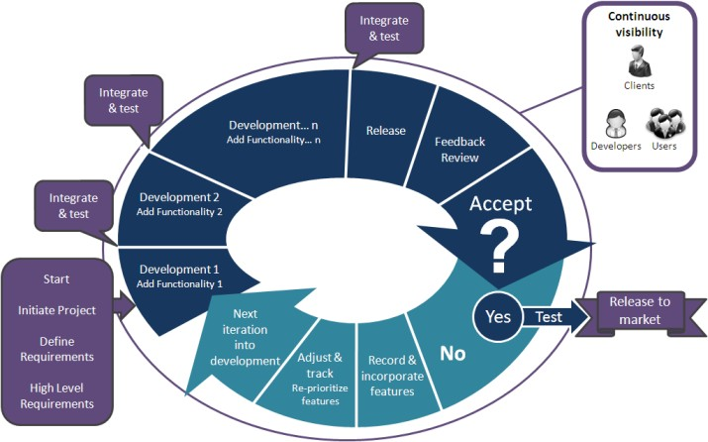Record and in cooperate new features into the system then again system definition of requirements and high-level requirements documentation is provided then integration and testing of the system is done, the system is released to clients, users, or sponsor for feedback review If they accept the system it is released to the market if not, **iteration 3** begins.

Figure 1: Showing Agile system development methodology

3.3 Requirement Analysis, Specification and Feasibility Report

3.3.1 Introduction

In this chapter we shall look at overall respondent perception of the old and new system and then look at whether a new system is worth undertaking in the feasibility analysis. This will be made possible by the data collected from the users, further; it assesses what the users would like to see in the new system which will prove vital when making the designs.

3.3.2 Data Collection

This section deals with the various knowledge acquisition methods that were applied while determining the functionality of the business processes, acceptance, and feasibility of building a new system.

3.3.3 Primary tools used:

#### Questionnaires:

There were two different questionnaires circulating where the first set of questions was administered to the 10 administration police while the second set was administered to 9 court police assisted by court clerks. The questionnaires studied the understanding of the proposed system, and knowledge level on ICT of the police officers who were directly and indirectly affected by the proposed system. The questionnaire was balanced between open ended and closed ended question outweighing the disadvantages of either for maximum understanding of the current system. The questions were simple, specific, short, and free of bias and kept at an appropriate reading level. The respondent rate was good as about 80% of the questionnaires were submitted fully filled.

#### Interviews:

Interviews were arranged to different respondents this included 3 IT specialists in the police department and 1 management officer with a view to elicit their comprehensive feedback on the understanding of the importance of the proposed system overall of its usage after implementation. Again, open ended and closed ended questions were applied to get the most out of the interview.

3.4 Analysis of Research Findings

|  |  |
| --- | --- |
| **Experts involved in the knowledge acquisition process** | **Number of experts involved** |
| Management | 1 |
| Administration Police | 10 |
| Court police and clerks. | 9 |
| IT specialist in police department | 3 |
| **TOTAL** | **23** |

Table 1: Number of respondents involved in the knowledge acquisition process

3.4.1 Feasibility report relating to the study of efficiency of old system and new system.

|  |  |  |  |
| --- | --- | --- | --- |
|  | **Qualities** | **New system efficiency** | **Old system efficiency** |
| 1 | Security | 90% | 60% |
| 2 | Access | 90% | 60% |
| 3 | Organization | 90% | 30% |
| 4 | Identification | 90% | 40% |
| 5 | Availability | 90% | 20% |
| 6 | Reliability | 90% | 10% |

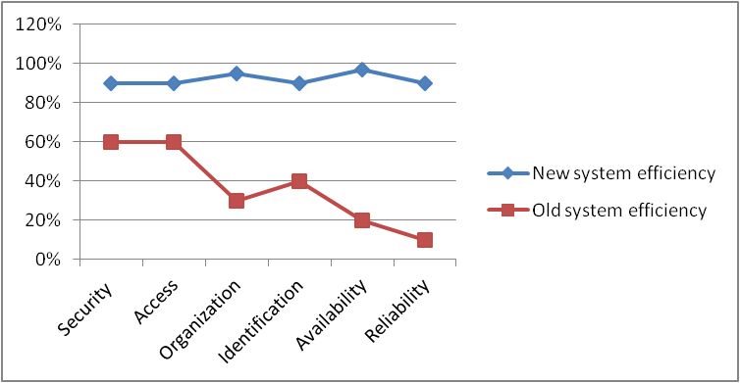Table 2: Ratings for advantages for implementing a new system over the old system

Figure 2: Graphical representation of the comparison between new and old system advantages

3.5 Feasibility Study

Feasibility study is made to see if the project on completion will serve the purpose of the organization for work, effort and the time that spend on it. Feasibility study lets the developer foresee the future of the project and the usefulness. A feasibility study of a system proposal is according to its workability, which is the impact on the organization, ability to meet their user needs and effective use of resources.

**3.5.1 Technical Feasibility:**

This was done to establish if the new system can be developed with the current equipment, existing software, and available personnel. The system must be evaluated from the technical point of view first. The assessment of this feasibility must be based on an outline design of the system requirement in the terms of input, output, programs, and procedures. Having identified an outline system, the investigation must go on to suggest the type of equipment, required method developing the system, of running the system once it has been designed.

The current equipment used included hardware such as computers and software such as Dreamweaver and Wamp server which were readily available. The implementation of the proposed system will further require servers which will be networked in every police station, all of which will help in the storage, backup and updating of the data. The project should be developed such that the necessary functions and performance are achieved within the constraints. The project is developed within latest technology. Through the technology may become obsolete after some period, since never version of same software supports older versions, the system may still be used. So, there are minimal constraints involved with this project. The system has been developed using Java the project is technically feasible for development.

Technical issues raised during the investigation are:

* Does the existing technology sufficient for the suggested one?
* Can the system expand if developed?

**3.5.2 Economic Feasibility:**

The developing system must be justified by cost and benefit. Criteria to ensure that effort is concentrated on project, which will give best, return at the earliest. One of the factors, which affect the development of a new system, is the cost it would require. It is a cost benefit analysis that evaluates the financial input into the proposed system and benefits of its implementation. This established the need of a new system for the police and judicial system since its implementation will save the taxpayer the huge budgetary allocation on stationery, filing cabinets and remunerations by 80% from a small budget of developing the system of Kshs23,000.00. The following are some of the important financial questions asked during preliminary investigation: The costs conduct a full system investigation. The cost of the hardware and software. The benefits in the form of reduced costs or fewer costly errors.

3.5.3 Operation Feasibility:

This was done to see if the system will be able to solve the defined problem of inefficiency in the judicial and police departments in terms of data handling and storage. The departments will therefore have competitive advantage from the opportunities that the system will present.

3.5.4 Schedule Feasibility:

The system was found to be feasible within the dates that the management expected the new system to be up and running. There was more than ample time to develop the new system for the police departments and even test it thoroughly for errors.

3.5.5 Behavioral Feasibility

This includes the following questions:

* Is there sufficient support for the users?
* Will the proposed system cause harm?

The project would be beneficial because it satisfies the objectives when developed and installed. All behavioral aspects are considered carefully and conclude that the project is behaviorally feasible.

# CHAPTER FOUR

SYSTEM DESIGN

## 4.1 Introduction

Design is the first step into the development phase for any engineered product or system. Design is a creative process. A good design is the key to effective system. The term “design” is defined as “the process of applying various techniques and principles for the purpose of defining a process or a system in sufficient detail to permit its physical realization”. It may be defined as a process of applying various techniques and principles for the purpose of defining a device, a process, or a system in sufficient detail to permit its physical realization. Software design sits at the technical kernel of the software engineering process and is applied regardless of the development paradigm that is used. The system design develops the architectural detail required to build a system or product. As in the case of any systematic approach, this software too has undergone the best possible design phase fine tuning all efficiency, performance, and accuracy levels. The design phase is a transition from a user-oriented document to a document to the programmers or database personnel. System design goes through two phases of development: Logical and Physical Design.

4.2 Logical Design:

The logical flow of a system and define the boundaries of a system. It includes the following steps:

* Reviews the current physical system – its data flows, file content, volumes, Frequencies etc.
* Prepares output specifications – that is, determines the format, content, and Frequency of reports.
* Prepares input specifications – format, content, and most of the input functions.
* Prepares edit, security, and control specifications.
* Specifies the implementation plan.
* Prepares a logical design walk through of the information flow, output, input, Controls, and implementation plan.
* Reviews benefits, costs, target dates and system constraints.

**4.3 Physical Design:**

Physical system produces the working systems by define the design specifications that tell the programmers exactly what the candidate system must do. It includes the following steps:

* Design the physical system.
* Specify input and output media.
* Design the database and specify backup procedures.
* Design physical information flow through the system and a physical design
* Plan system implementation.
* Prepare a conversion schedule and target date.
* Determine training procedures, courses, and timetable.
* Devise a test and implementation plan and specify any new hardware/software.
* Update benefits, costs, conversion date and system constraints

**Design/Specification activities:**

* Concept formulation.
* Problem understanding.
* High level requirements proposals.
* Feasibility study.
* Requirement’s engineering.
* Architectural design.

**Module Design**

* Administrator
* Supervisor
* Police

**The administrator module includes;**

* View and reply user booking or complaint: This module helps the admin to view and reply user’s booking or complaint details
* View and reply user crimes: This module helps the admin to view and reply user’s crimes details
* New admin: This module used for add new admin
* Add and delete latest news on the portal message board: This module helps the admin to add and delete latest hotness.
* View and delete user’s feedback: The module aids the admin to add and delete user’s feedback
* Add, delete, and view most wanted persons: This module helps the amin to add, delete and view most wanted person details
* Add, delete, and view missing persons: This module helps the amin to add, delete and view missing person details
* Add and view Criminal registration: This module helps the amin to add and view criminal registrations
* Add and view FIR: This module helps the amin to add and view Fir reports
* Add and view history sheet: This module helps the amin to add and view history reports
* View and delete all complaint reply: This module helps the amin to view and delete complaint reply.
* Add and view prisoner report: This module helps the amin to add and prisoner reports
* Change password: This module helps the amin to update his or her password

**The visitor module includes,**

* View news on the message board: This module helps the visitor to see the latest news which can updated by the admin.
* The registered user module includes,
* Add Complaint: This module helps the user to report online complaints.
* Add Crime report: This module helps the user to report online crimes.
* Add Missing person: This module helps the user to report online missing persons details also we must add photos of missing person using heterogeneous database.
* View Missing persons: This module help the user to view all the missing person details.
* View Most wanted persons: This module help the user to view all most wanted persons which can be given by the administrator.
* Edit Complaint: This module helps the user to edit his complaint details.
* Edit Account: This module helps the user to update his or her profile.
* View complaint status: This module allows us to view the status of all complaint that you have posted earlier.
* View crime status: This module allows us to view the status of the all crimes that you have posted earlier.
* Add and View feedback: This module helps the user to add and view feedbacks

## 4.3 Resources Required

#### 4.3.1 Hardware resources

1. A Personal Computer with the following specifications.

(Minimum)

* RAM 8 Gigabytes.
* Intel Quad Core i5 7th Generation Processor speed 3.0 GHz and Above.
* Graphics Card: 1GB Nvidia or AMD Ryzen.
* Hard disk capacity 1 TB
* 4 24” Monitors 1080p Full HD Display

(Recommended)

* RAM 16 GB.
* Intel Quad Core i7 11th Generation Processor speed 5.0 GHz and Above.
* Graphics Card: 2GB Nvidia or AMD Ryzen.
* Hard disk capacity 2 TB
* NVMe 256GB SSD
* 4 32” Monitors 4K Ultra HD Display

1. Laser Printer.
2. Fast Internet Access.
3. UPS.

#### 4.3.2 Software resources.

1. Operating system: Windows 10
2. Document viewer: Microsoft Word.
3. Database Management system: MYSQL.
4. Antivirus: Kaspersky
5. Web Browser: Chrome
6. Development Languages: Back-end (Php, JavaScript.) Front-end (Html, CSS,)
7. Integrated Development Environment (IDE): Visual Studio Code
8. Web Server: Apache

#### 4.3.3 Functional Requirements

1. The system will capture bio data and other information about any person with a case and store them in a database.
2. The system will only authorize specific personnel who are responsible for taking the data using an authentication login.
3. The system will be able to search persons by national ID number provided to the system and display a report.
4. The system will be able to delete any unwanted records from the database and update accordingly.
5. The system will be able to give desired reports according to the user request.

|  |  |
| --- | --- |
| Functional Requirements | Description |
| Log In | The system requires all users to log in before accessing any system functionality. The system provides a Graphical user interface with fields for username and password. |
| Sign Up | The system allows a new user to register and set their username and password. This is allowed by register user functionality. |
| Report Crime | The system allows officers to report a crime happening around them. They are also able to attach any evidence in the form of file such as an image, audio, video or document. This capability is provided by report crime functionality. |
| View Reported Crime | The system allows officers to see all the crimes they have reported so far. The users can track the changing status of the reports as updated by the investigating officer working on the incidence. The users will also be also to know the investigating officer working on their cases. |
| Report Lost item | The system allows officers to report any lost property remotely. |

Table 3:Functional Requirements as per Reporter

|  |  |
| --- | --- |
| Functional Requirements | Description |
| Log In | The system requires all users to log in before accessing any system functionality. The system provides a graphical user interface with fields for username and password. |
| Sign Up | The system allows registration of a new head officers by the administrators. It’s the responsibility of the system administrators to register officers who are entitled to use the system. |
| Searching Incidence/ Crime | The system allows an officer to search for a crime based on selected attribute out of the possible first nine attributes of the case. By just typing on the search text field, the system will be filtering instantly. The instant search does not retrieve messages from the database but searches from the cached table data. |
| Assign crime/Incidence | The system allows the system administrator to assign a crime to an investigative officer who will be working on the reported case. |
| Check details of reporter | The system allows the officers to check the details of the reporter by righting clicking the reported crime. |
| See the list of reporters | The application enables retrieval of all reporters registered in the system. |
| Search reporters | The system allows searching of reporters based on any attribute. Just by typing in the search field, the system filters instantly. |
| See the list of police officers | The system enables retrieval of the names of all police officers registered as the users of the application. |

Table 4:Functional Requirements as per the Head of Departments

#### Non-Functional Requirements

These are requirements that define system characteristics or attributes. They describe how a system should behave and what limits are there on its functionality. The proposed system has been developed using MYSQL which provides a database management system as well as a test server to be able to test how data is going to interact with the users once they have been captured in the database.

**Security:** The system ensures the security of its user’s credentials. The system has several security features to protect user’s credentials at various levels such as:

Database Level: The database is password protected. Passwords are encrypted.

Application Level: Every user has credentials only known to them. To access the system, the users must log in. Changes done to a reported crime are stored for tracking due to sensitivity of the case, and they must be known. Deployment Level: The system runs on Java platform which is very secure.

**Response Time:** Response time concerning user requests should be within 1 to 3 seconds.

Throughput: The system allows many users to access it concurrently.

Reliability: The system is 99% operational.

Accuracy: The system present accurate data to the users to maintain its credibility and that of the users as well.

Access Reliability: The system is accessible 99% of the time.

4.4 Input Design

**Introduction to PHP**

**What is php*?***

PHP stands for **P**HP: **H**ypertext **P**reprocessor. PHP is a server-side scripting language, like ASP. PHP supports many databases (MySQL, Informix, Oracle, Sybase, Solid, PostgreSQL, Generic ODBC, etc.) PHP is an open-source software. PHP is free to download and use.

**Some of the main features of PHP are listed below:**

that page. The PHP module executes the script, which then sends out the result in the form

of HTML back to your browser, which you see on the screen. Here is a basic

php diagram which illustrate the process. PHP runs on different platforms (Windows, Linux, Unix, etc.) PHP is compatible with almost all servers used today (Apache, IIS, etc.) PHP is FREE to download from the official PHP resource .PHP Is easy to learn and runs efficiently on the server side

**Introduction to PHP**:

PHP sits between your browser and the web server. When you type in the URL of a PHP website in your browser, your browser sends out a request to the web server. The web server then calls the PHP script on

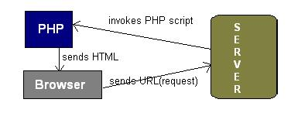

Figure 3:PHP server communication

PHP is a server-side, cross-platform, HTML-embedded scripting language.

there are over half a million domains running PHP and it is freely available for download.

Much of PHP’s syntax is borrowed from C, Java, and Perl with a couple of unique PHP-specific

features thrown in. The goal of the language is to allow web developers to write dynamically generated

pages quickly. PHP eliminates the need for numerous small CGI programs by allowing you to place simple scripts directly in your HTML files.

It also makes it easier to manage large web sites by placing all components of a web page in a single html file. PHP is an excellent alternative to such similar programming solutions as Microsoft’s proprietary scripting engine ASP and Allaire's rather expensive ColdFusion. As mentioned before, PHP is a cross-platform language. This does not stop with the core PHP code but can be extended to all of PHP's libraries and all code written in PHP. Neither ASP nor ColdFusion can make this claim. PHP has a large feature set which includes built-in support for numerous databases (*including Access, LDAP, Oracle, and MSSQL*), networking support, zip archiving, and an excellent set of built-in functions. Furthermore, due in part to it being open source and freely available for download on the web, the language enjoys an active developing environment.

Since the syntax structure borrows heavily from C, it is easy for even the novice programmer to learn the language. PHP is also the oldest HTML-embedded scripting language, giving it a head start on all the others. If you are a content developer, you probably will not want to learn PHP scripting by heart. But it is nice to know how PHP can help you create more powerful web applications and user-friendly designs.

The input design is the link between the information system and the user. It comprises the developing specification and procedures for data preparation and those steps are necessary to put transaction data in to a usable form for processing can be achieved by inspecting the computer to read data from a written or printed document or it can occur by having people keying the data directly into the system. The design of input focuses on controlling the amount of input required, controlling the errors, avoiding delay, avoiding extra steps, and keeping the process simple. The input is designed in such a way so that it provides security and ease of use with retaining the privacy. Input Design considered the following things:

* What data should be given as input?
* How the data should be arranged or coded?
* The dialog to guide the operating personnel in providing input.
* Methods for preparing input validations and steps to follow when error occur.

**Objectives**

* Input Design is the process of converting a user-oriented description of the input into a computer-based system. This design is important to avoid errors in the data input process and show the correct direction to the management for getting correct information from the computerized system.
* It is achieved by creating user-friendly screens for the data entry to handle large volume of data. The goal of designing input is to make data entry easier and to be free from errors. The data entry screen is designed in such a way that all the data manipulates can be performed. It also provides record viewing facilities.
* When the data is entered it will check for its validity. Data can be entered with the help of screens. Appropriate messages are provided as when needed so that the user will not be in maize of instant. Thus, the objective of input design is to create an input layout that is easy to follow

4.5 Output Design

A quality output is one, which meets the requirements of the end user and presents the information clearly. In any system results of processing are communicated to the users and to other system through outputs. In output design it is determined how the information is to be displaced for immediate need and the hard copy output. It is the most important and direct source information to the user. Efficient and intelligent output design improves the system’s relationship to help user decision-making.

* Designing computer output should proceed in an organized, well thought out manner; the right output must be developed while ensuring that each output element is designed so that people will find the system can use easily and effectively. When analysis design computer output, they should Identify the specific output that is needed to meet the requirements.
* Select methods for presenting information.
* Create document, report, or other formats that contain information produced by the system.

The output form of an information system should accomplish one or more of the following objectives.

* Convey information about past activities, current status, or projections of the Future.
* Signal important events, opportunities, problems, or warnings.
* Trigger an action.
* Confirm an action.

## 4.6 Use case diagrams

This use case diagram describes the specific tasks initiated by the actor (admin) and describes a single goal the actor wants to achieve.

Officer

Figure 4: Use case diagram showing how the actor will interact with the system.

**Use case login Documentation.**

1. **Name**: Login.
2. **Description**: This use case handles the access to the system. The user must be an administrator who is authorized to use the system.
3. **Actors**: Administrators.
4. **Priority**: Very important.
5. **Preconditions**: The administrator has identified the presence of a new case in the reporting desk of the police department and needs to login to enter the new case details into the system database.
6. **Use case interactions**: Interacts with the database to authenticate the user.
7. **Flow of events: basic path**: The use case starts when the user browses into the system's front page.
8. The system will display the login page with text boxes for username and password, a button for submitting the information.
9. The user then enters a username and password.
10. The system checks the information by confirming with the information in the database.
11. The system displays the new cases entry page with field to be inserted with information for submission to the database.
12. The use case ends.

**Use case Insert Information Documentation**

* **Name**: Insert Information.
* **Description**: This use case handles the insertion and submission of the entered information in the new cases page to the database.
* **Actors**: Administrators.
* **Preconditions**: The administrator must be authenticated and logged in.
* **Use case interactions**: Interacts with the database to insert information to the database.
* **Flow of events: basic path**: The use case starts after the user successfully logs into the systems.
* The system will display the new cases page with text box fields for Identification number, date, Date of Birth, first name, second name, last name, and telephone number, reasons for booking, court ruling and button for submitting the information.
* The user then enters all the required information.
* The system then inserts the information into their relevant field tables in the database.
* The use case ends.

**The registered user module includes,**

* Add Complaint: This module helps the user to report online complaints.
* Add Crime report: This module helps the user to report online crimes.
* Add Missing person: This module helps the user to report online missing persons details also we must add photos of missing person using heterogeneous database.
* View Missing persons: This module help the user to view all the missing person details.
* View Most wanted persons: This module help the user to view all most wanted persons which can be given by the administrator.
* Edit Complaint: This module helps the user to edit his complaint details.
* Edit Account: This module helps the user to update his or her profile.
* View complaint status: This module allows us to view the status of all complaint that you have posted earlier.
* View crime status: This module allows us to view the status of the all crimes that you have posted earlier.

**Use case Update Record Documentation**

* **Name**: Update Record.
* **Description**: This use case handles the updating of records which includes deleting unwanted or irrelevant records. Updating serves to also include the rulings field which will usually be entered much later after the suspect has been given judgment.
* **Actors**: Administrators.
* **Preconditions**: The administrator identifies irrelevant or incomplete information.
* **Use case interactions**: Interacts with the database to update information to the database.
* **Flow of events:** The administrator will identify the record entry that he wants to update especially the rulings field, and then he enters the information accordingly.

The administrator submits the informationand the use case ends.

**Use case Run Reports Documentation**

* **Name**: Run Reports.
* **Description**: This use case handles the producing and displaying of updated records.
* **Actors**: Administrators.
* **Preconditions**: When the administrator wants to confirm updated fields or wants to query specific records in the database.
* **Use case interactions**: Interacts with the database to retrieve information from the database.
* **Flow of events:** The administrator will query the database for the record entry that he wants to review.

4.7 Data Flow Diagram

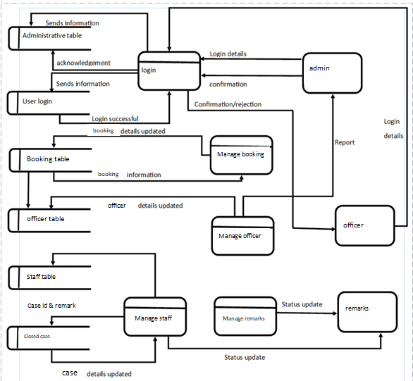

Figure 5:data flow diagram

4.7.1 Context flow diagram

Figure 6:context flow diagram

officer

Administrator

Register Complaints/bookings

Assigning cases and user roles

Solutions, Feedback

**Level 1 DFD- Administrator**

Add FIR Reports

Add mortem analysis

View Complaints

View user details

View Feedback

User name, Password

Administrator

User

Registration details

Bookings

Feedback

Add Solutions

FIR

Mortem Details

Figure 7:level 1 admin DFD

View Reports

Add Reports

FIR No: Details

FIR Details

Booking Details

Bookings

FIR

Criminal details

Reports

Administrator

User

Mortem Details

Figure 8:Level 2 DFD- Administrator

Verify

Complaints

Username/Password

Registration

Login

Bookings

Username/Password

User

Figure 9:Level 1 DFD- User

Solutions

Complaint Details

Booking Status

Complaint ID

User name Password

User

Booking

Feedback

Complaint Status

Figure 10:Level 2 DFD- User

4.7.2 Sequence diagram

This sequence diagram shows how objects communicate with one another and how this interaction specifies the communication pattern between sets of objects of the system that are in collaboration.

7: Display Reports

1: username and password

: Login Page

: User Authentication

: Enter Information

Admin

2: Authenticate user

3: obtain information

4: Enter information

5: Update information

6: Reports

Figure 11: Sequence Diagram

4.7.3 Class Diagrams

This class diagram describes the classes that exist in this system and their interrelationships.

4.8 Relational Database Management System (Rdbms):

Figure 12:Class Diagram

Enter Information

Login Page

User Authentication

1

1

1

*

A relational model represents the database as a collection of relations. Each relation resembles a table of values or file of records. In formal relational model terminology, a row is called a tuple, a column header is called an attribute and the table is called a relation. A relational database consists of a collection of tables, each of which is assigned a unique name. A row in a tale represents a set of related values.

**Relations, Domains & Attributes:**

A table is a relation. The rows in a table are called tuples. A tuple is an ordered set of n elements. Columns are referred to as attributes. Relationships have been set between every table in the database. This ensures both Referential and Entity Relationship Integrity. A domain D is a set of atomic values. A common method of specifying a domain is to specify a data type from which the data values forming the domain are drawn. It is also useful to specify a name for the domain to help in interpreting its values. Every value in a relation is atomic, that is not decomposable.

4.8.1 Relationships:

* Table relationships are established using Key. The two main keys of prime importance are Primary Key & Foreign Key. Entity Integrity and Referential Integrity Relationships can be established with these keys.
* Entity Integrity enforces that no Primary Key can have null values.
* Referential Integrity enforces that no Primary Key can have null values.
* Referential Integrity for each distinct Foreign Key value, there must exist a matching Primary Key value in the same domain. Other key is Super Key and Candidate Keys.
* Relationships have been set between every table in the database. This ensures both Referential and Entity Relationship Integrity.

4.8.2 Normalization:

As the name implies, it denoted putting things in the normal form. The application developer via normalization tries to achieve a sensible organization of data into proper tables and columns and where names can be easily correlated to the data by the user. Normalization eliminates repeating groups at data and thereby avoids data redundancy which proves to be a great burden on the computer resources. These includes:

* Normalize the data.
* Choose proper names for the tables and columns.
* Choose the proper name for the data.

**First Normal Form**:

The First Normal Form states that the domain of an attribute must include only atomic values and that the value of any attribute in a tuple must be a single value from the domain of that attribute. In other words, 1NF disallows “relations within relations” or “relations as attribute values within tuples”. The only attribute values permitted by 1NF are single atomic or indivisible values.

The first step is to put the data into First Normal Form. This can be donor by moving data into separate tables where the data is of similar type in each table. Each table is given a Primary Key or Foreign Key as per requirement of the project. In this we form new relations for each nonatomic attribute or nested relation. This eliminated repeating groups of data.

A relation is said to be in first normal form if only if it satisfies the constraints that contain the primary key only.

**Second Normal Form**:

According to Second Normal Form, for relations where primary key contains multiple attributes, no nonkey attribute should be functionally dependent on a part of the primary key.

In this we decompose and setup a new relation for each partial key with its dependent attributes. Make sure to keep a relation with the original primary key and any attributes that are fully functionally dependent on it. This step helps in taking out data that is only dependent on a part of the key. A relation is said to be in second normal form if and only if it satisfies all the first normal form conditions for the primary key and every non-primary key attribute of the relation is fully dependent on its primary key alone.

**Third Normal Form**:

According to Third Normal Form, Relation should not have a monkey attribute functionally determined by another nonkey attribute or by a set of nonkey attributes. That is, there should be no transitive dependency on the primary key.

In this we decompose and set up relation that includes the nonkey attributes that functionally determines other nonkey attributes. This step is taken to get rid of anything that does not depend entirely on the Primary Key.

A relation is said to be in third normal form if only if it is in second normal form and more over the non key attributes of the relation should not be depend on another non-key attribute.

4.9 Tables Structure

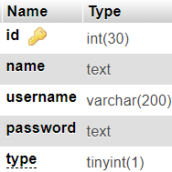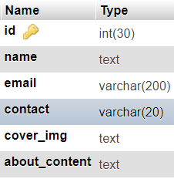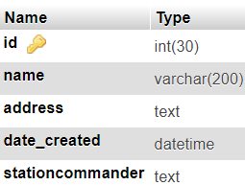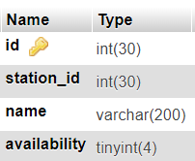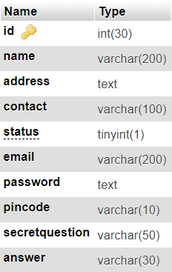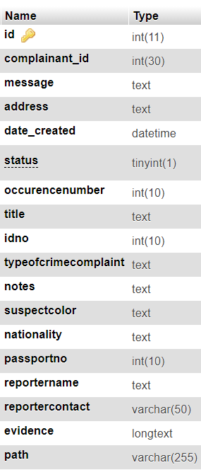

Table 5:responders’ team

Table 6:staff

Table 7:system settings

Table 8:stations

Table 9:desk officer

Table 10:booking action

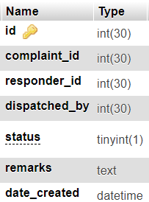Table 11:booking

## 4.10 Budget Design

|  |  |
| --- | --- |
| **ITEM** | **TOTAL COST** |
| Printing cost | 2000.00 |
| Photocopy cost | 1000.00 |
| Installation cost | 5000.00 |
| System maintenance cost | 5000.00 |
| Personnel training cost | 10000.00 |
| **TOTAL COST** | **23000.00** |

Table 12: Budget

## 4.11 Project Schedule (Gantt Chart)

|  |  |  |  |  |  |  |  |  |  |  |  |  |
| --- | --- | --- | --- | --- | --- | --- | --- | --- | --- | --- | --- | --- |
| **TIME IN WEEKS** | | | | | | | | | | | | |
| **ACTIVITY** | **1** | **2** | **3** | **4** | **5** | **6** | **7** | **8** | **9** | **10** | **11** | **12** |
| Requirement’s elicitation |  |  |  |  |  |  |  |  |  |  |  |  |
| Feasibility Study |  |  |  |  |  |  |  |  |  |  |  |  |
| System Analysis |  |  |  |  |  |  |  |  |  |  |  |  |
| System Design |  |  |  |  |  |  |  |  |  |  |  |  |
| Coding |  |  |  |  |  |  |  |  |  |  |  |  |
| Testing |  |  |  |  |  |  |  |  |  |  |  |  |
| Documentation |  |  |  |  |  |  |  |  |  |  |  |  |
| Implementation |  |  |  |  |  |  |  |  |  |  |  |  |

Table 13: Gantt chart

CHAPTER FIVE

5.0 SYSTEM IMPLEMENTATION AND TESTING

5.1 Introduction

Software Testing is the process of executing software in a controlled manner, to answer the question - Does the software behave as specified? Software testing is often used in association with the term’s verification and validation. Validation is the checking or testing of items, includes software, for conformance and consistency with an associated specification. Software testing is just one kind of verification, which also uses techniques such as reviews, analysis, inspections, and walkthroughs. Validation is the process of checking that what has been specified is what the user wanted.

Validation **:** Are we doing the right job?

Verification **:** Are we doing the job right?

Software testing should not be confused with debugging. Debugging is the process of analyzing and localizing bugs when software does not behave as expected. Although the identification of some bugs will be obvious from playing with the software, a methodical approach to software testing is a much more thorough means for identifying bugs. Debugging is therefore an activity which supports testing, but cannot replace testing.

Other activities which are often associated with software testing are static analysis and dynamic analysis. Static analysis investigates the source code of software, looking for problems and gathering metrics without executing the code. Dynamic analysis

looks at the behavior of software while it is executing, to provide information such as execution traces, timing profiles, and test coverage information.

Testing is a set of activity that can be planned in advanced and conducted systematically. Testing begins at the module level and work towards the integration of entire computers-based system. Nothing is complete without testing, as its vital success of the system testing objectives, there are several rules that can serve as testing objectives. They are

* Testing is a process of executing a program with the intend of finding an error.
* A good test case is one that has high possibility of finding an undiscovered error.
* A successful test is one that uncovers an undiscovered error.

If a testing is conducted successfully according to the objectives as stated above, it would have uncovered errors in the software also testing demonstrate that the software function appears to be working according to the specification, that performance requirement appears to have been met.

There are three ways to test program.

* For correctness
* For implementation efficiency
* For computational complexity

Test for correctness is supposed to verify that a program does exactly what it was designed to do. This is much more difficult than it may at first appear, especially for large programs. Implementation is the stage of the project where the theoretical design is turned into a working system. It can be the most crucial stage in achieving a successful new system gaining the users confidence that the new system will work and will be effective and accurate. It is primarily concerned with user training and documentation. Conversion usually takes place about the same time the user is being trained or later. Implementation simply means convening a new system design into operation, which is the process of converting a new revised system design into an operational one.Implementation is the stage of the project where the theoretical design is tuned into a working system. At this stage the main work load, the greatest upheaval and the major impact on the existing system shifts to the user department. If the implementation is not carefully planned and controlled it can create chaos and confusion.

5.2 Implementation Procedures

Implementation of software refers to the final installation of the package in its real environment, to the satisfaction of the intended uses and the operation of the system. In many organizations someone who will not be operating it, will commission the software development project. In the initial stage people doubt about the software but we must ensure that the resistance does not build up, as one must make sure that

* The active user must be aware of the benefits of using the new system.
* Their confidence in the software is built up.
* Proper guidance is imparted to the user so that he is comfortable in using the application.

Before going ahead and viewing the system, the user must know that for viewing the result, the server program should be running in the server. If the server object is not up running on the server, the actual process will not take place.

#### How to Run

1. Download the source code and extract the zip le.
2. Download or set up any local web server that runs PHP script.
3. Open the web-server database and create a new database name it crms_db.
4. Import the SQL le located in the admin/database folder of the source code.
5. Copy and paste the source code to the location where your local web server accessing your
6. local projects. Example for XAMPP('C:\xampp\htdocs')
7. Open a web browser and browse the project. E.g. [http://localhost/pcp/index.php] for the website and [http://localhost/pcp/admin/login.php] for the admin side5.3 User Training
8. **Admin Default Access**

Username: admin

Password: admin123

User training is designed to prepare the user for testing and converting the system. To achieve the objective and benefits expected from computer-based system, it is essential for the people who will be involved to be confident of their role in the new system. As system becomes more complex, the need for training is more important. By user training the user comes to know how to enter data, respond to error messages, interrogate the database and call up routine that will produce reports and perform other necessary functions.

5.4 Training on the Application Software

After providing the necessary basic training on computer awareness the user will have to be trained on the new application software. This will give the underlying philosophy of the use of the new system such as the screen flow, screen design type of help on the screen, type of errors while entering the data, the corresponding validation check at each entry and the ways to correct the date entered. It should then cover information needed by the specific user/ group to use the system or part of the system while imparting the training of the program on the application. This training may be different across different user groups and across different levels of hierarchy.

5.5 Operational Document

Once the implementation plan is decided, it is essential that the user of the system is made familiar and comfortable with the environment. Education involves right atmosphere and motivating the user. A documentation providing the whole operations of the system is being developed in such a way that the user can work with it in well consistent way. The system is developed user friendly so that the user can work the system from the tips given in the application itself. Useful tip and guidance are given inside the application itself to help the user. Users must be made aware that what can be achieved with the new system and how it increases the performance of the system. The user of the system should be given a general idea of the system before he uses the system.

5.6 System Maintenance

Maintenance is the enigma of system development. The maintenance phase of the

software cycle is the time in which a software product performs useful work. After a

system is successfully implemented; it should be maintained in a proper manner.

System maintenance is an important aspect in the software development life cycle.

The need for system maintenance is for it to make adaptable to the changes in the

system environment. Software maintenance is of course, far more than "Finding

Mistakes". Maintenance may be defined by describing four activities that are undertaken after a program is released for use.

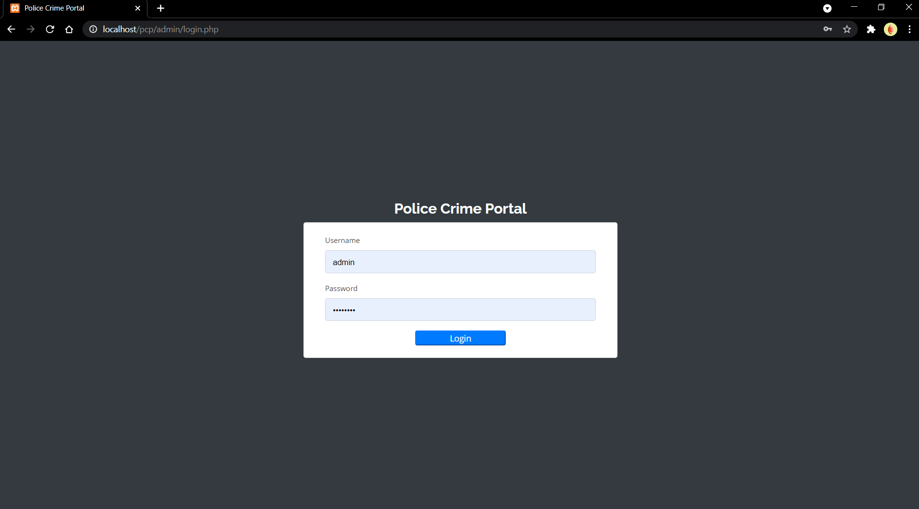5.7 Screenshots

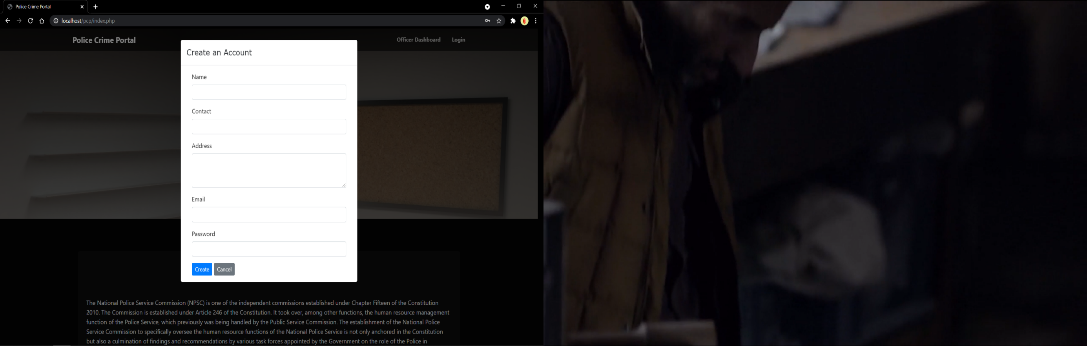

Figure 13:account creation

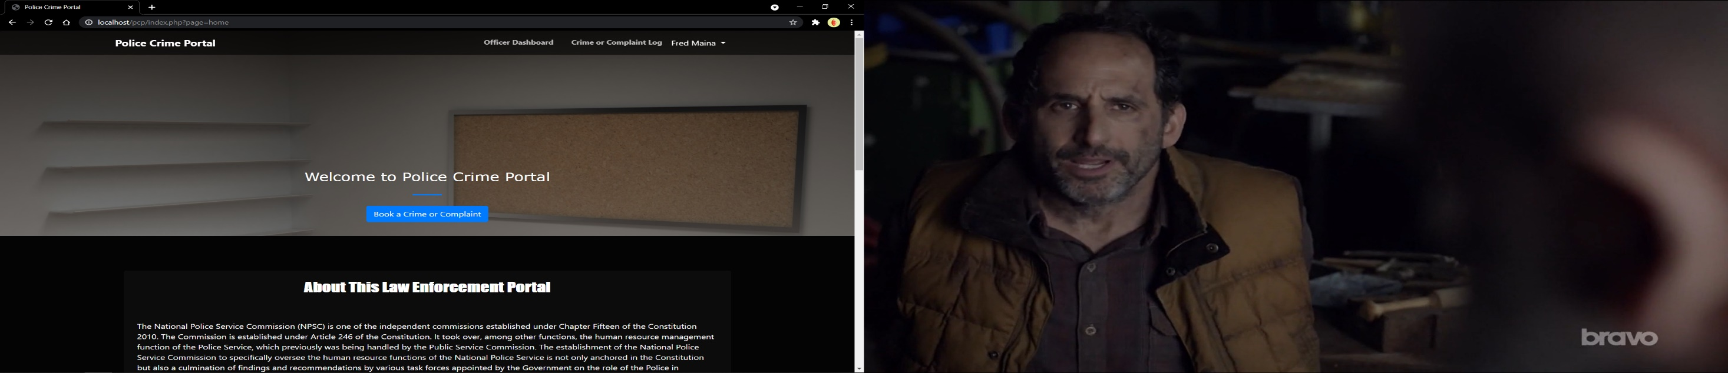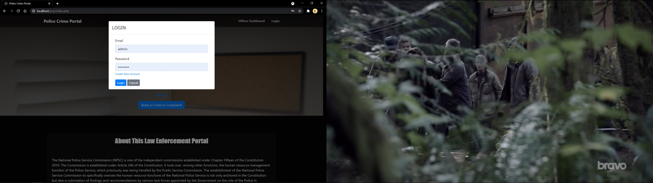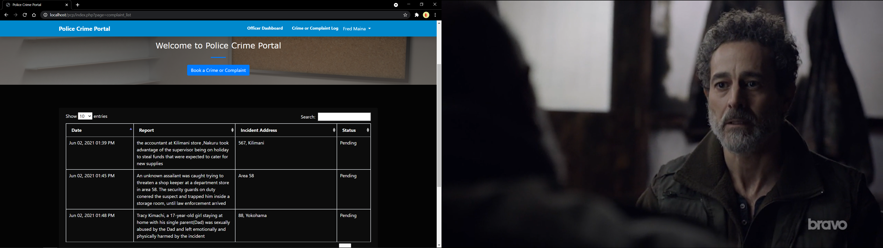

Figure 14:officer login

Figure 15:admin login

Figure 16:officer dashboard

Figure 17:bookings log

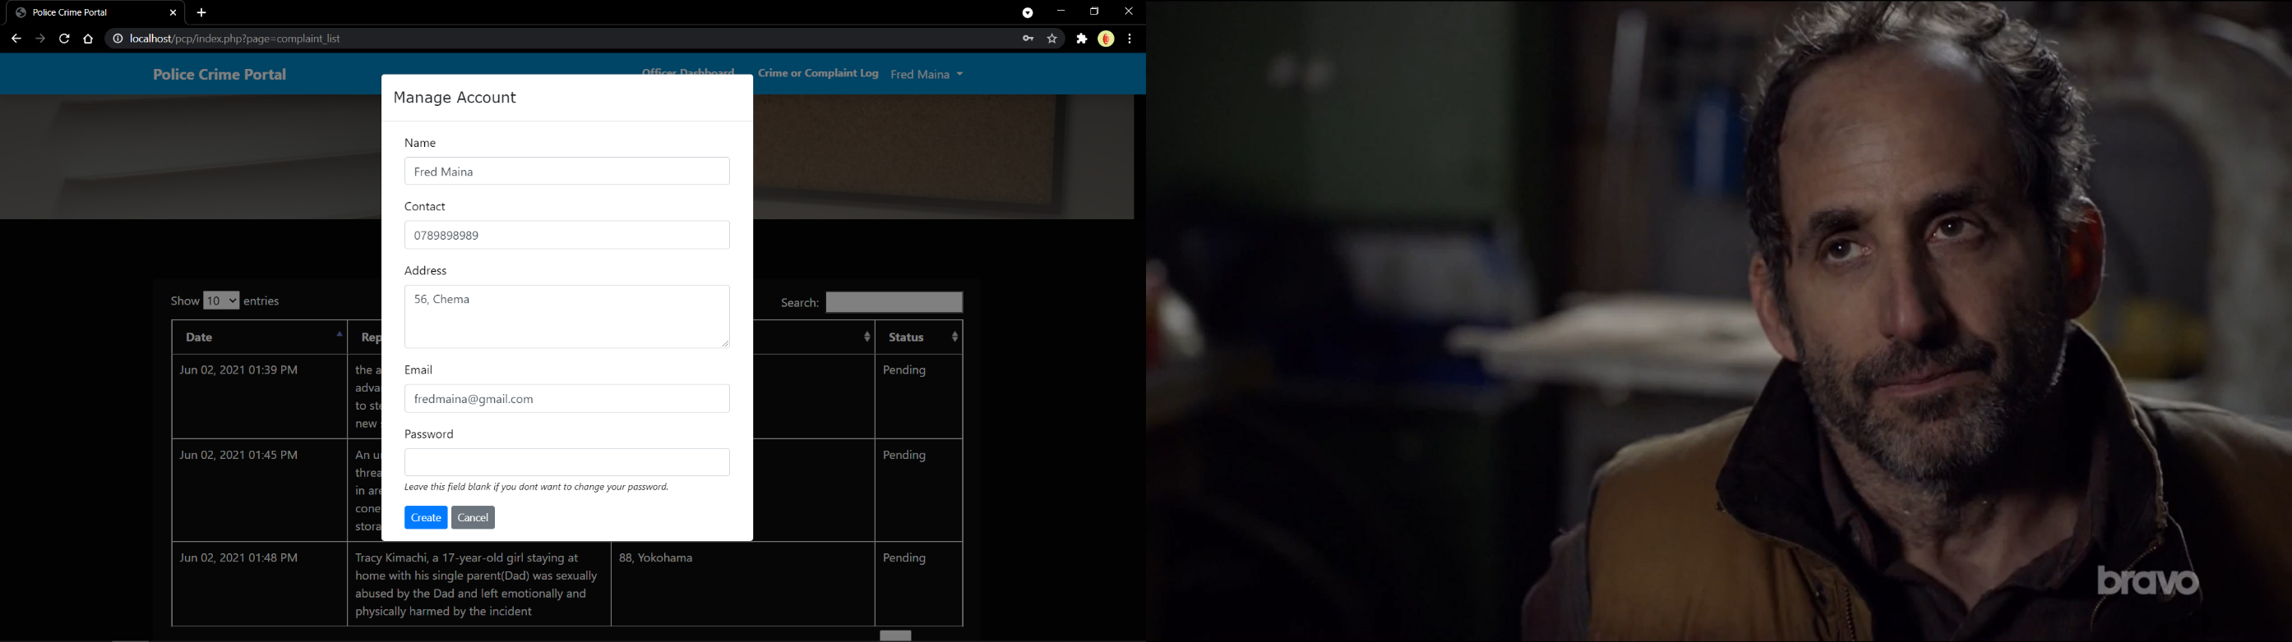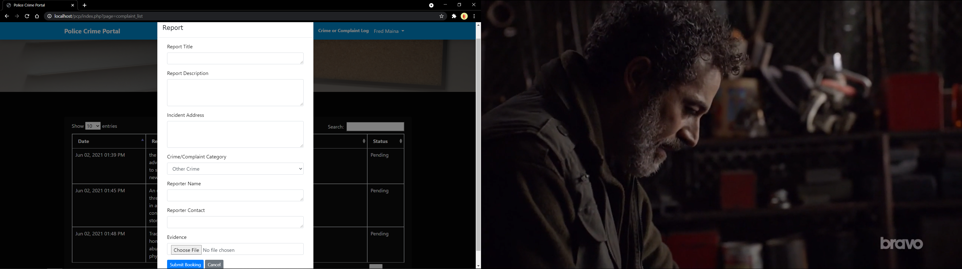

Figure 18:officer account management

Figure 19:booking entry

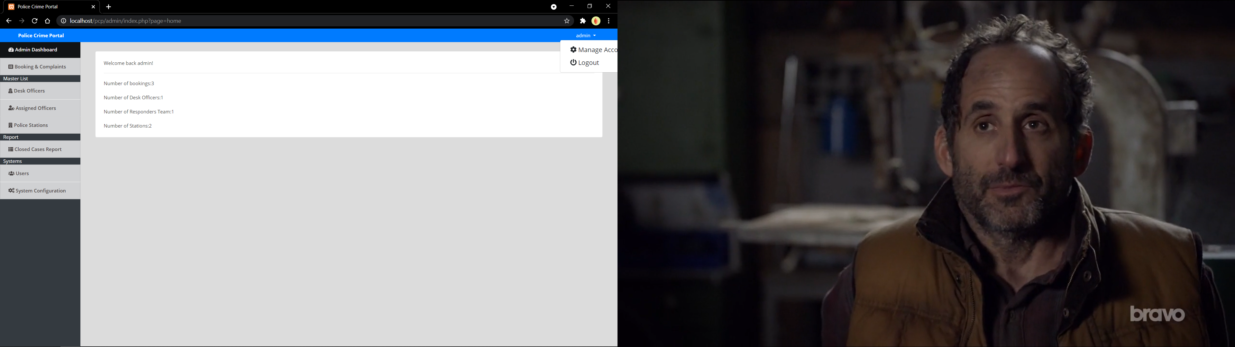

Figure 20:admin dashboard

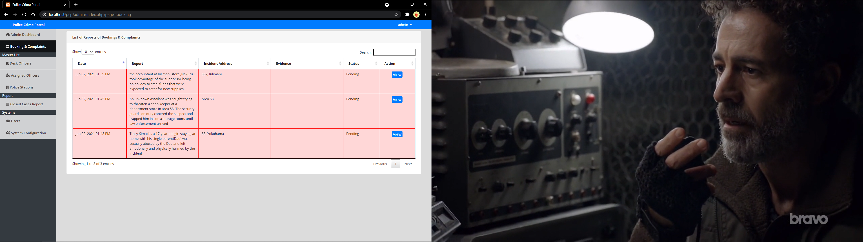

Figure 21:bookings pending verification

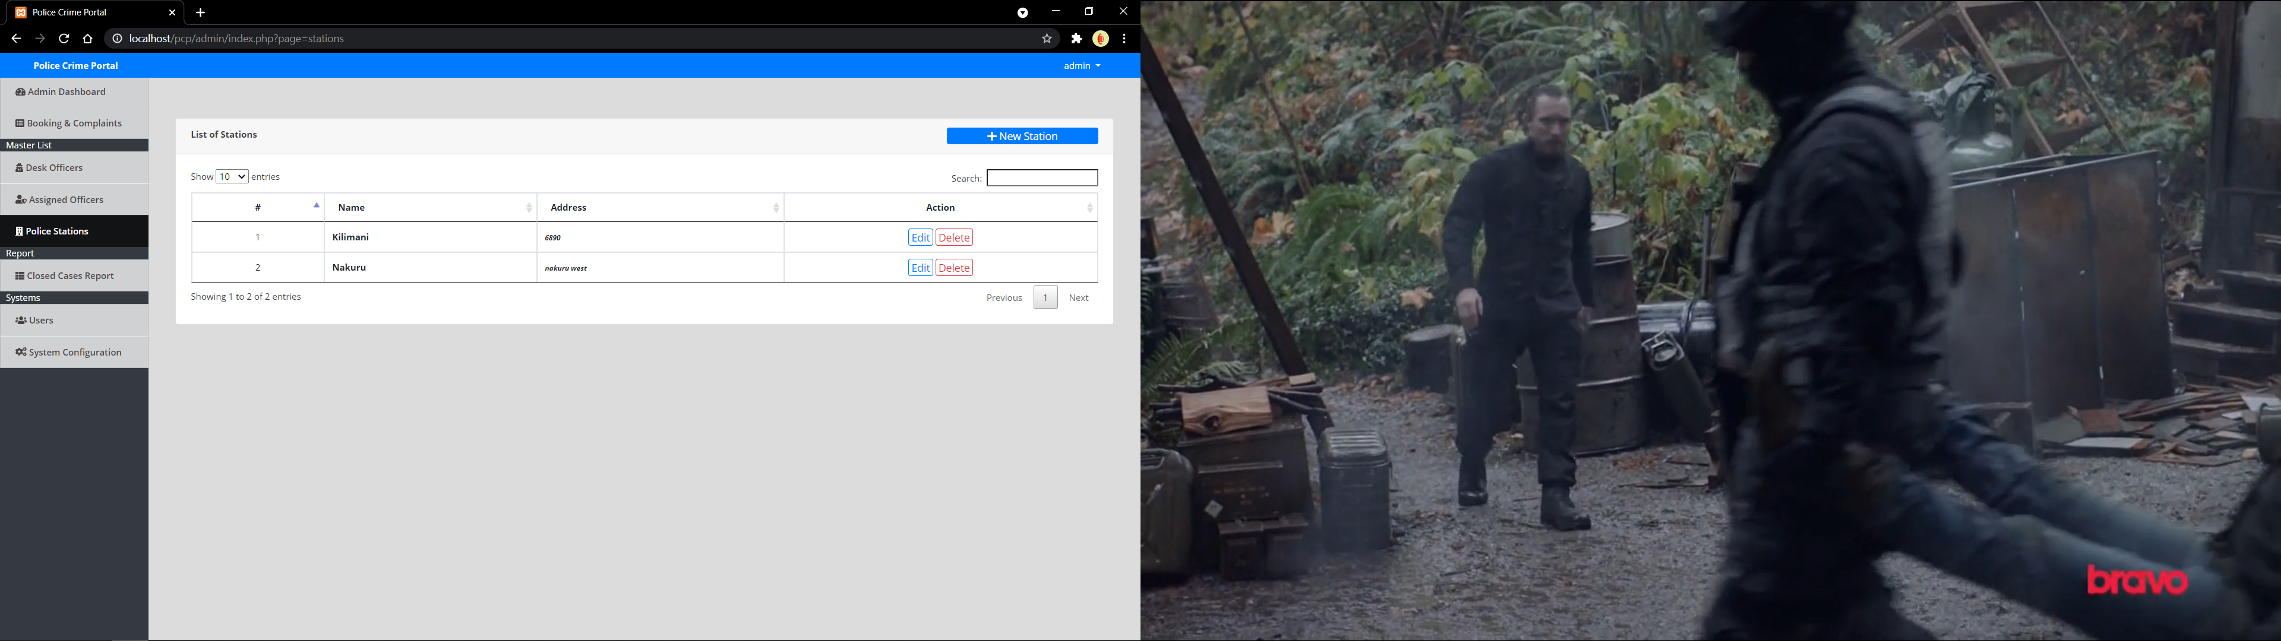

Figure 22:stations management

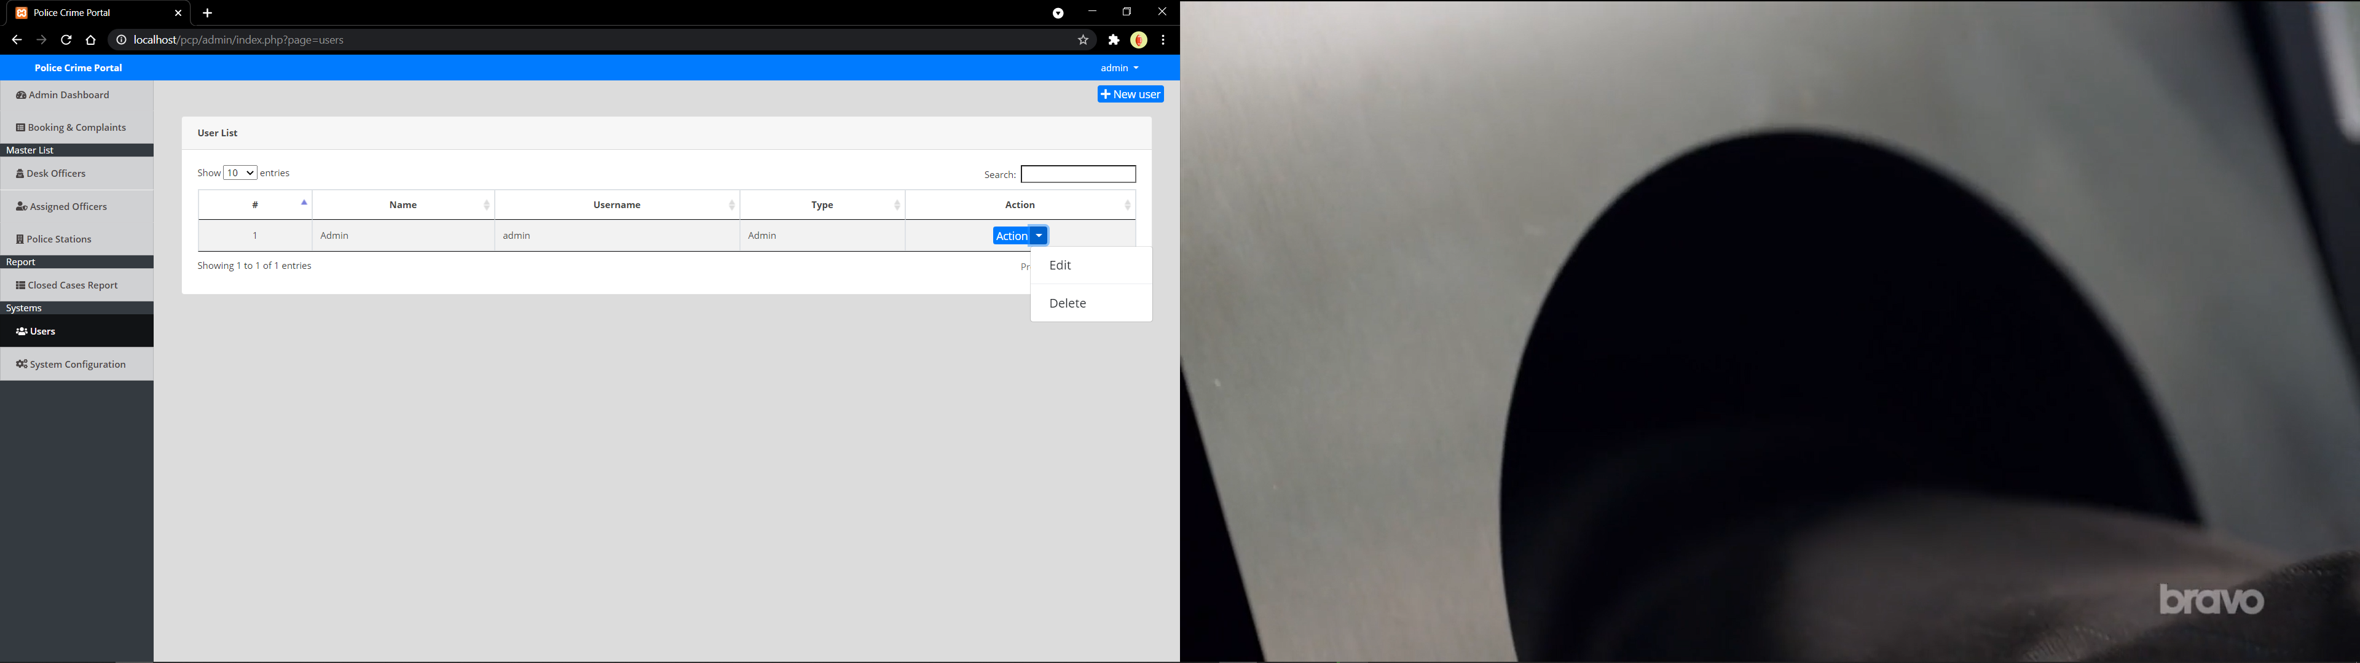

Figure 23:staff management

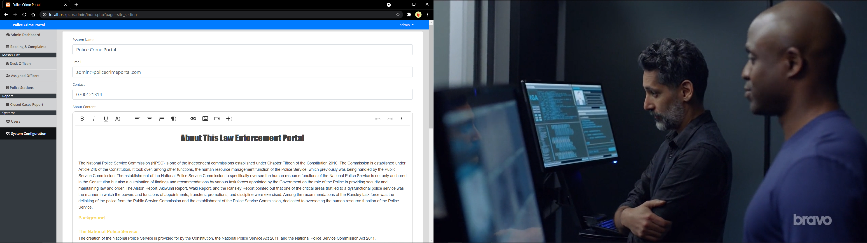

Figure 24:dashboard management

# CONCLUSION

The proposed system meets the requirements needed by the law enforcement institution to solve its problem. The system will be able to provide the required solutions to the problems specified such as poor storage, inefficient departmental operation, and disorganization of records. The project has been completed successfully with the maximum satisfaction of the organization. The constraints are met and overcome successfully. The system is designed as like it was decided in the design phase. The project gives good idea on developing a full-fledged application satisfying the user requirements.

The system is very flexible and versatile. This software has a user-friendly screen that enables the user to use without any inconvenience. Validation checks induced have greatly reduced errors. Provisions have been made to upgrade the software. The application has been tested with live data and has provided a successful result. Hence the software has proved to work efficiently.

# RECOMMENDATIONS

The police should keep confidential data received from users (like user data saved in the system after registration) safe and should not spill to wrong hands. Disclosing this information should be lawful or by the consent of the persons. They should keep crime reporters (who could be witnesses or victims) safe to protect them. Disclosing this information can lead to culprits of the reported crime harming the whistle-blowers.

Some crimes will require urgent response to save life, terror or attack. Therefore, close monitoring of the incoming incidences is of utmost importance.

Crime reporting awareness is necessary to inform the users of the new easy way of reporting criminal incidences and educating them on how to use it. Also giving assurance to the general public that registering as a user and reporting crime, whether the crime was detected or not shall not be used against them at all. Encouraging them to help make the society a safer place.

Giving police officers training that is aimed at imparting them with skills needed to use the back-end application for crime reporting. The back-end application is for incidence management.

The public should also have sufficient training to understand the operation and use of the application plus its real-time significance in intelligence gathering and resolving crime.

Finally, this system can be modified further in relation to different types of industries and organization sizes to determine its usability even for large enterprises, non-governmental organizations.

# REFERENCES

Adano, W., Dietz, T., Witsenburg, K., & Zaal, F. (2012). Climate change, violent conflict and local institutions in Kenya's drylands. *Journal of Peace Research*, 65-80.

Akech, J. (2005). Public law values and the politics of criminal justice: creating a democratic framework for policing in Kenya. *Commonwealth Law Journal*, 225-256.

Ali, S., Briand, L. C., Hemmati, H., & Panesar-Walawege, R. K. (2010). A system review of the application and empirical investigation of search-based test case generation. *IEEe Transaction on Software Engineering*, 742-762.

Al-Mudimigh, A., Zairi, M., & Al-Mashari, M. (2001). ERP software implementation: an interactive framework. *European Journal of Information Systems*, 216-226.

Ambler, S. (2011). *Examining the Agile Manifesto.* Boston.

Amey, P., Hale, C., & Meiczkowski, T. (1996). *Development and evaluation of a crime manageent model.* london: Police Research Series Paper.

Arnot, C., Luckert, M., & Boxall, P. (2011). What is Tenure Security? Concepual Implications for Empirical Analysis. *Land Economics*, 297-311.

August, T., & Tunca, T. (2006). Network Software Security and User Intencives. *Management Science*, 1703-1720.

Bachmann, J., & Honke, J. (2010). Developing Kuwait Social Security System. *Savings and Deevelopment*, 201-211.

Eck, J. E., & Weisburd, D. (2009). *Crime Prevention Studies: Crime and Place.* Monsey,N.Y.: Criminal Justice Press.

Elmasri, N. (n.d.). *Fundamentals of database systems.*

Larman, & Craig. (2004). Agile and Iterative development. *A Manager's Guide*, 27.

Mall, R. (n.d.). *Software Engineering.*

McEwen, J., & Taxman, F. (1995). *Application of computer Mapping to Police.*

Ratcliffe, J. (2010). crime mapping: spatial and temporal challenges. *Handbook of quantitative criminology*, 5-24.

Rich, T. (1995). *The Use of Computerized Mapping in Crime and Control and Prevention Programs.* Washington, D.C.: National Institute of Justice.

Somerville, I. (n.d.). *Software Engineering.*

APPENDICES

## Appendix I: Research Questionnaire for Police Officers

This questionnaire is designed to collect data on the study titled ‘CRIME REPORTING AND INTELLIGENCE SYSTEM: CASE OF CENTRAL POLICE DIVISION- NAKURU’. The data collected through this questionnaire is intended for academic purposes only and will not be divulged to any other person. Please complete all sections of this document. All questions are interrelated and are very important for the study. You have been identified as one of the respondents and you are requested kindly to fill in the information as appropriate.

**SECTION A: BACKGROUND DATA**

* 1. Gender:
  2. Male []
  3. Female []
  4. How long have you worked in this police station?

1. Less than one year []
2. 1 -2 years []
3. 2 – 3 years []
4. State…………… …………………………………………………….

3. A part from training as an officer, do you have any other certifications?

1. Certificate []
2. Diploma []
3. Degree level []
4. Master and above []
5. State…………………………………………………………………….

**SECTION B: CASE REPORTING**

1. How long have you been in the police service?

……………………………………………………….

1. How many occurrence reports do you handle in a month?
   1. Less than 5 []
   2. 5-10 []
   3. 11-20 []
   4. 21-30 []
   5. 31-40 []
   6. 41-50 []
   7. More than 50 []
   8. State average cases
2. How many hours from the time of the occurrence were the incidents reported?
   1. Less than 1 hour []
   2. 1-5 []
   3. 6-10 []
   4. 11-15 []
   5. 16-24 []
   6. 1 day []
   7. 2 days []
   8. 3 days 1 week []
   9. More than a week []
   10. State the duration

………………………………………………........................................

1. Was there immediate response to report incidences?
2. Yes []
3. No []
4. How long did it take before response by officers?
5. Within one hour []
6. 1-2 hours []
7. 2-3 hours []
8. 3-4 hours []
9. 4-5 hours []
10. 12 hours []
11. Any other duration………………………………………………………………………
12. List the problems you have encountered when carrying out manual reporting of cases?

………………………………………………………………………………………………

………………………………………………………………………………………………

1. Do you think remote reporting (through your mobile phone) would offer a solution to problems faced currently?
2. Yes []
3. No []
4. How would remote reporting (through your mobile phone) improve crime response and resolution?

………………………………………………………………………………………………

………………………………………………………………………………………………

THANK YOU.

## Appendix IV: Sample Codes

**Db_connect.php**

<?php

$conn= new mysqli('localhost','root','','crms_db')or die("Could not connect to mysql".mysqli_error($con));

**Booking.php**

<?php

include 'db_connect.php';

?>

<div class="container-fluid">

    <div class="col-lg-12">

        <div class="card">

            <div class="card-header">

                <b>List of Reports of Bookings & Complaints</b>

            </div>

            <div class="card-body">

                <table class="table table-bordered table-hover" id="complaint-tbl">

                    <thead>

                      <tr>

                        <th width="15%">Date</th>

                        <th width="20%">Report</th>

                        <th width="20%">Incident Address</th>

                        <th width="20%">Evidence</th>

                        <th width="10%">Status</th>

                        <th width="10%">Action</th>

                      </tr>

                    </thead>

                    <tbody>

                      <?php

                      $status = array("","Pending","Received","Action Made");

                      $qry = $conn->query("SELECT * FROM booking order by unix_timestamp(date_created) desc ");

                      while($row = $qry->fetch_array()):

                      ?>

                      <tr class="<?php echo $row['status'] == 1 ? 'border-alert' : '' ?>">

                        <td><?php echo date('M d, Y h:i A',strtotime($row['date_created'])) ?></td>

                        <td><?php echo $row['message'] ?></td>

                        <td><?php echo $row['address'] ?></td>

                        <td><?php echo $row['evidence'] ?></td>

                        <td><?php echo $status[$row['status']] ?></td>

                        <td class="text-center">

                            <button class="btn btn-primary btn-sm m-0 view_btn" type="button" data-id="<?php echo $row['id'] ?>">View</button>

                        </td>

                      </tr>

                    <?php endwhile; ?>

                    </tbody>

              </table>

            </div>

        </div>

    </div>

</div>

<style>

    .border-gradien-alert{

        border-image: linear-gradient(to right, red , yellow) !important;

    }

    .border-alert th,

    .border-alert td {

      animation: blink 200ms infinite alternate;

    }

    @keyframes blink {

      from {

        border-color: white;

      }

      to {

        border-color: red;

        background: #ff00002b;

      }

    }

</style>

<script>

    $('#complaint-tbl').dataTable();

    $('.view_btn').click(function(){

        uni_modal("View Details","manage_complaint.php?id="+$(this).attr('data-id'),"mid-large")

    })

</script>